**Week 2 Day 2 Tasks**

**Task 11 : Using Built-in Functions**

**Objective: Practice using Python’s built-in functions**.

**Steps:**

1. Use the len() function to find the length of a string.

1. Use max() and min() to find the largest and smallest values in a list.

1. Use sum() to find the sum of all elements in the list.

**Question: How would you find the median of a list using built-in functions?**

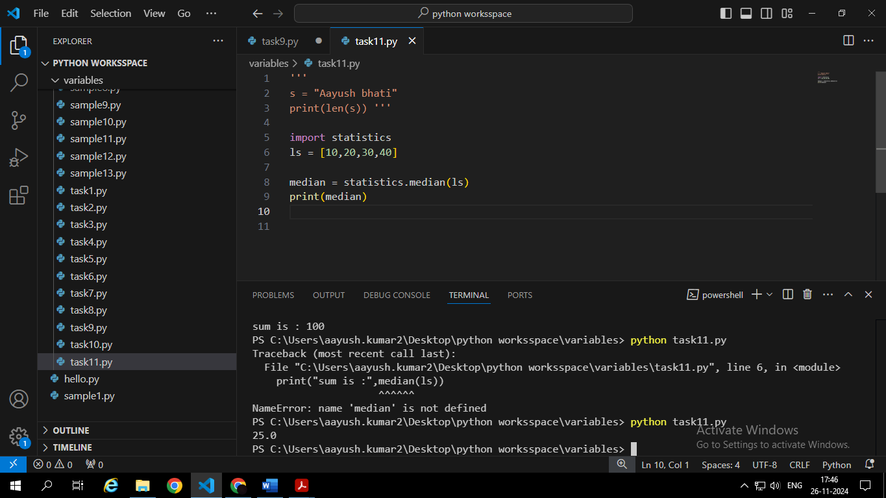

**12. Task: Working with Lists (Add, Modify, Remove)**

**• Objective: Understand how to manipulate lists in Python.**

• Steps:

1. Create a list of five numbers.

2. Add a new number to the list.

1. Remove the first number from the list.

1. Modify the third element in the list.

• **Question: What happens if you try to access an index that doesn’t exist in the list?**

A **IndexError: list index out of range** came

**Task 13: Tuples and Immutability**

• **Objective: Learn how to work with tuples and their immutability.**

**• Steps:**

1. Create a tuple with different data types (string, integer, float).

1. Try modifying an element in the tuple and see what happens.

**Question: Why can’t you change the values in a tuple?**

Because tupe is immutable in nature we can’t modified its value once it created.

**14. Task: Working with Dictionaries (Key-Value Pairs)**

• **Objective:** Learn how to work with dictionaries.

• **Steps:**

1. Create a dictionary with name, age, and location as keys.

1. Add a new key-value pair for "job".

1. Update the "age" value.

1. Remove the "location" key.

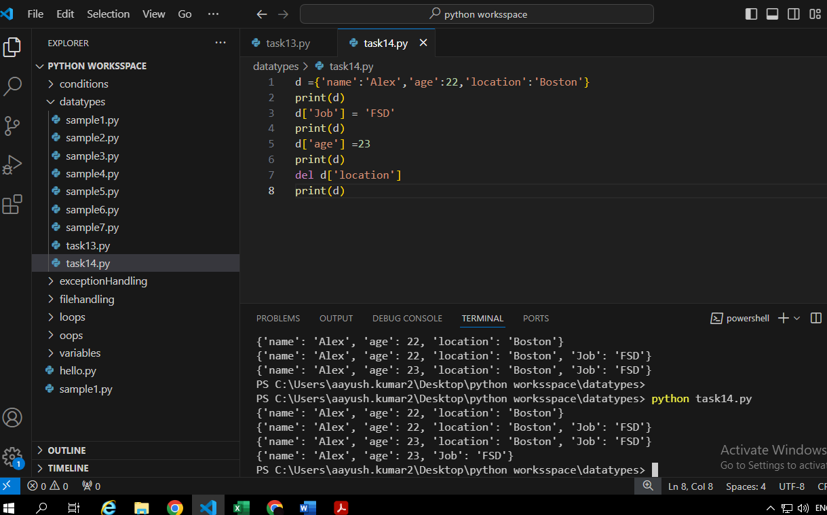

• **Question:** What happens if you try to access a key that doesn't exist in the dictionary?

A KeyError will appear.

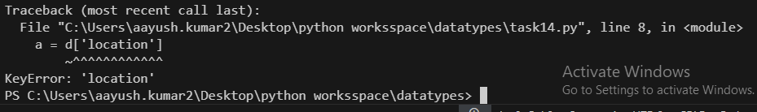

**15. Task: Sets and Set Operations**

• **Objective:** Understand how to use sets in Python.

• **Steps:**

1. Create two sets: one containing odd numbers and the other containing even numbers.

2. Use the union and intersection operations to combine the sets.

1. Check if an element exists in a set.

• **Question:** What happens when you try to add a duplicate element to a set?

It will not added because set don’t allow duplicate.

**Task 16: String Operations**

• **Objective:** Practice working with strings in Python.

• **Steps:**

1. Create a string and perform operations like upper(), lower(), and replace().

1. Concatenate two strings.

1. Use slicing to extract a substring.

• **Question:** What happens if you try to slice a string using an index that is out of range?

Program will execute successfully but don’t print anything.



**Task 17: Writing a Program with Functions and Lists**

• **Objective:** Combine functions and lists in a program.

• **Steps:**

1. Write a function that accepts a list of numbers and returns the largest number in the list.
2. Call the function with a sample list.

• **Question:** How would you modify the function to return the smallest number in the list?

We just simply use min() function in place of max().

**Task 18: Classes and Objects**

• **Objective:** Learn the basics of object-oriented programming with classes and objects.

• **Steps:**

1. Create a Car class with attributes like make, model, and year.

2. Define a method that displays the car’s information.

3. Create an object of the Car class and call the method.

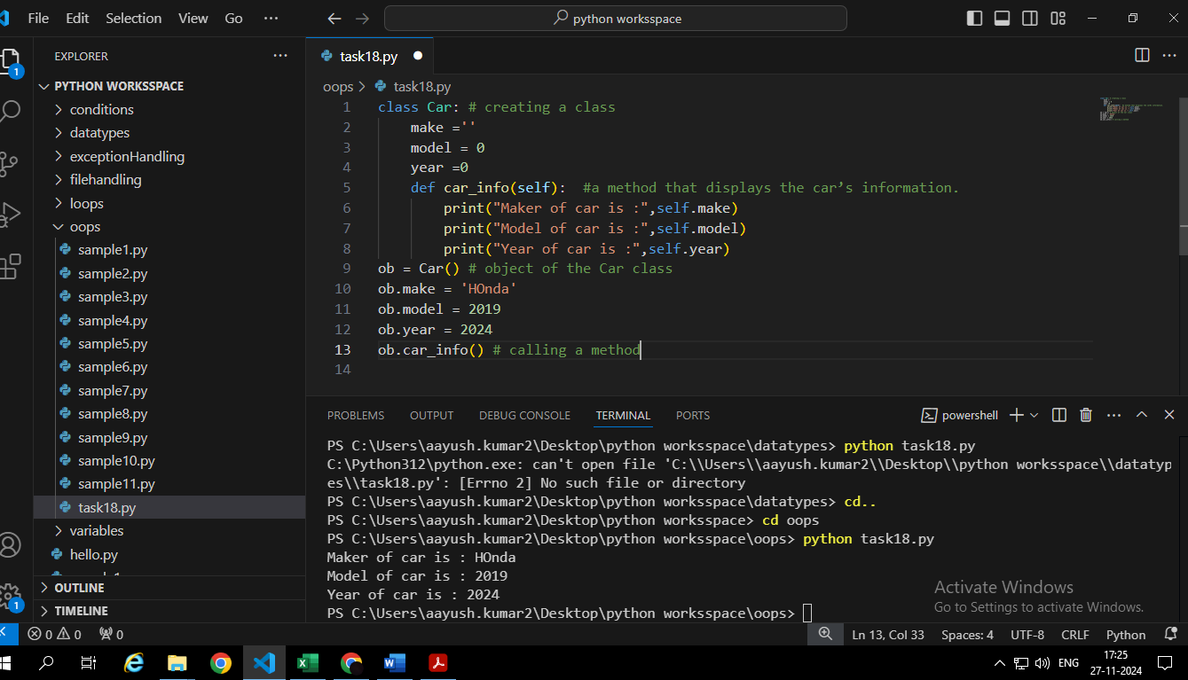

• **Question:** How would you modify the class to include a method that updates the car’s model?

**19. Task: Inheritance**

• **Objective:** Learn how to use inheritance in Python.

• **Steps:**

1. Create a base class Animal with a method speak().

2. Create a derived class Dog that inherits from Animal and adds a bark() method.

3. Create an object of the Dog class and call both methods.

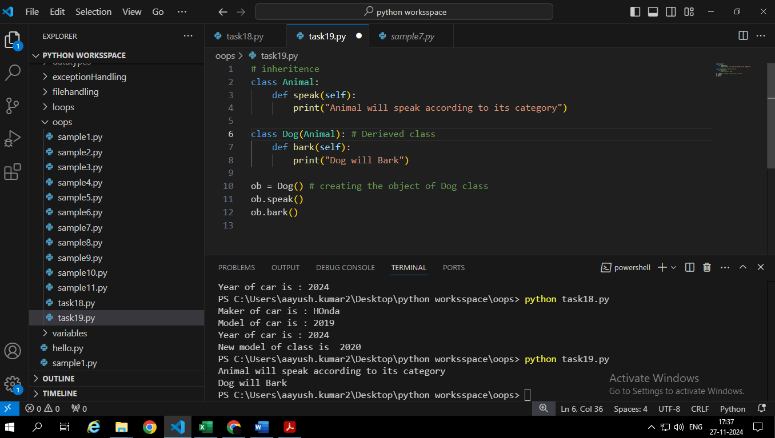

• **Question:** Can you override the speak() method in the derived class? How would you do it?

Yes, we can override the speak method in the derived class.

**Task 20: Constructor and Initialization**

• **Objective:** Understand how to initialize object attributes using the constructor (__init__).

• **Steps:**

1. Create a Book class with title and author as attributes.

2. Define the __init__ method to initialize the object.

3. Create an object of the Book class and print its attributes.

• **Question:** How would you modify the class to include a price attribute?

